Experiment No:
Date:
Aim
To design and study the UML Use Case Diagram for an ATM Machine system and understand the interaction between user, ATM interface, and bank server during the withdrawal process.
Objective
- To identify the actors involved in the ATM system.
- To analyze the functional requirements of the ATM.
- To represent the system behavior using a Use Case Diagram.
- To understand how authentication and transaction processing are performed.
- To study the interaction between hardware and software modules of ATM.
3. Components Used
Hardware Components:
- ATM Machine
- Card Reader
- Keypad
- Display Screen
- Cash Dispenser
- Receipt Printer
- Bank Server
- Network Connection
Software Components:
- ATM Operating System
- ATM Application Software
- Banking Database System
- Network Communication Software
- UML Modeling Tool (Draw.io / StarUML / etc.)
Modules
The ATM system consists of the following modules:
1. Card Reading Module
Reads the ATM card information when inserted.
2. Authentication Module
Verifies the user by checking the entered PIN with the bank server.
3. Transaction Selection Module
Displays options like withdrawal, balance enquiry, etc.
4. Account Selection Module
Allows the user to select account type (Savings / Current).
5. Amount Processing Module
Accepts withdrawal amount and sends request to bank server.
6. Balance Verification Module
Checks whether sufficient balance is available.
7. Cash Dispensing Module
Dispenses cash if balance is sufficient.
8. Receipt Generation Module
Prints the transaction details on a receipt.
Working Principle
- The user inserts the ATM card into the card reader.
- The ATM prompts the user to enter the PIN.
- The entered PIN is sent to the bank server for verification.
- If authentication is successful, the transaction menu is displayed.
- The user selects the withdraw option.
- The user selects the account type (Savings).
- The user enters the withdrawal amount.
- The ATM sends the request to the bank server.
- The bank server checks the account balance.
- If sufficient balance is available:
- The amount is deducted.
- Cash is dispensed.
- Receipt is printed.
- If insufficient balance:
- Transaction is cancelled.
- Error message is displayed.
Advantages
- Provides 24/7 banking services.
- Reduces workload of bank staff.
- Fast and convenient transactions.
- Secure authentication system.
- Easy access to cash anywhere.
- Minimizes manual errors.
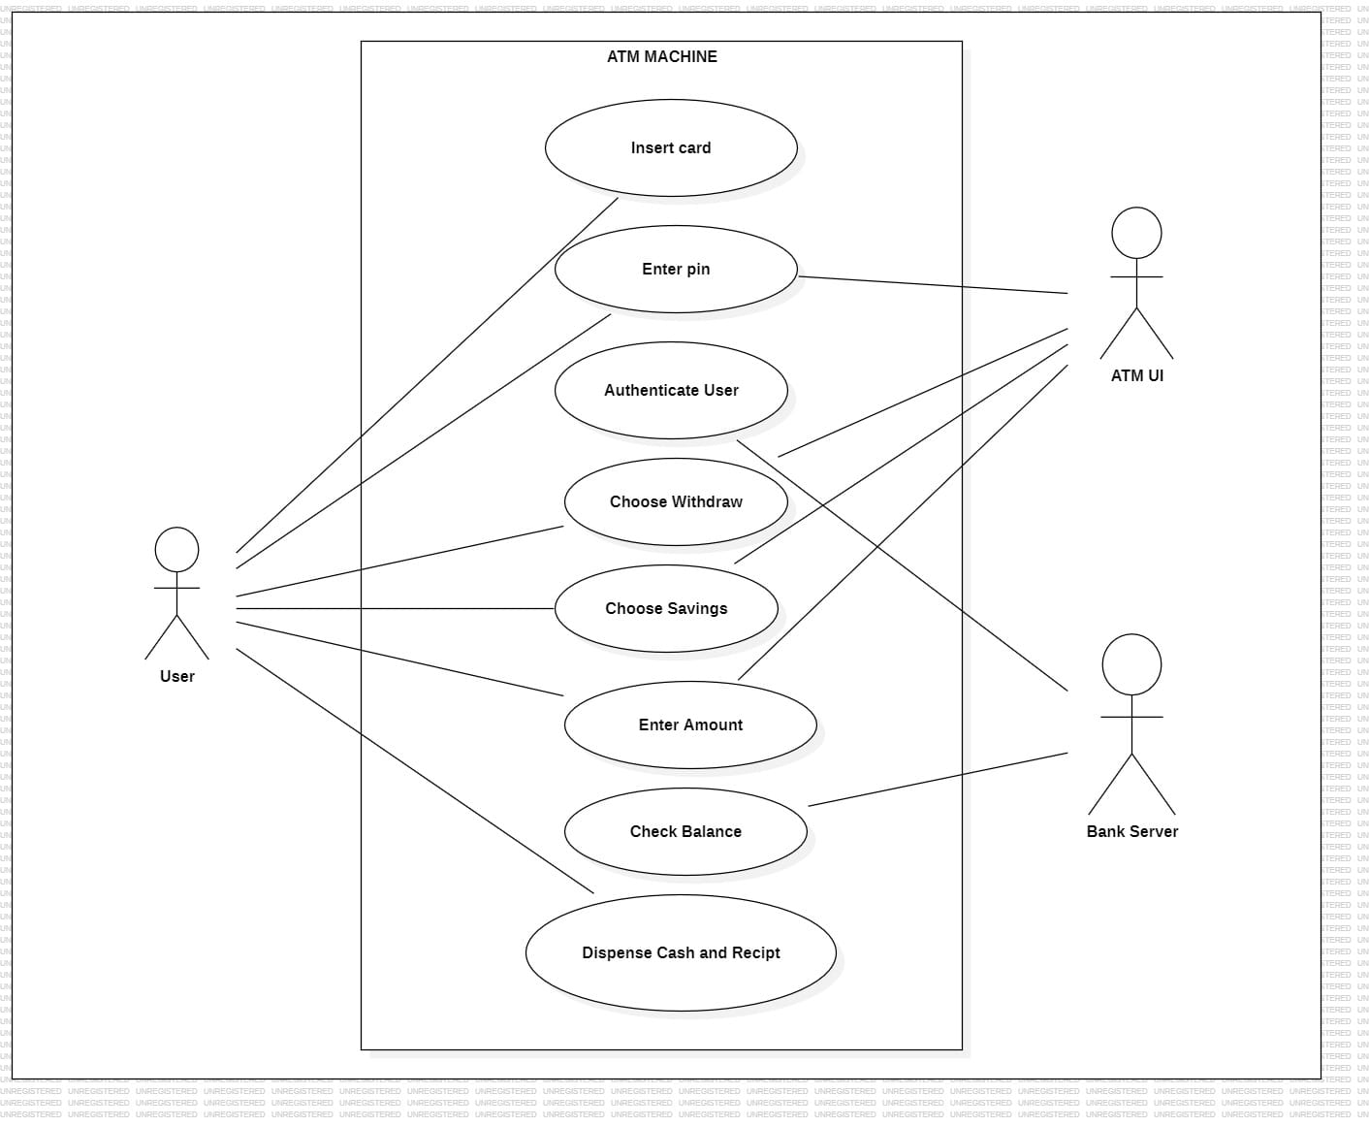
Conclusion
Thus, the ATM Machine Use Case Diagram was designed and studied successfully. The system clearly shows the interaction between User, ATM UI, and Bank Server. The modules and working principle explain how secure authentication and transaction processing are carried out efficiently.

